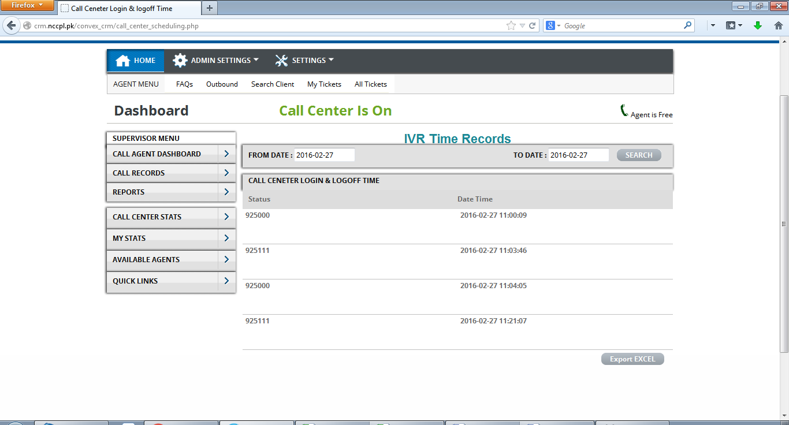  
ID of user logging-in and logging-out call centre should reflect on the report. (Pending additional)

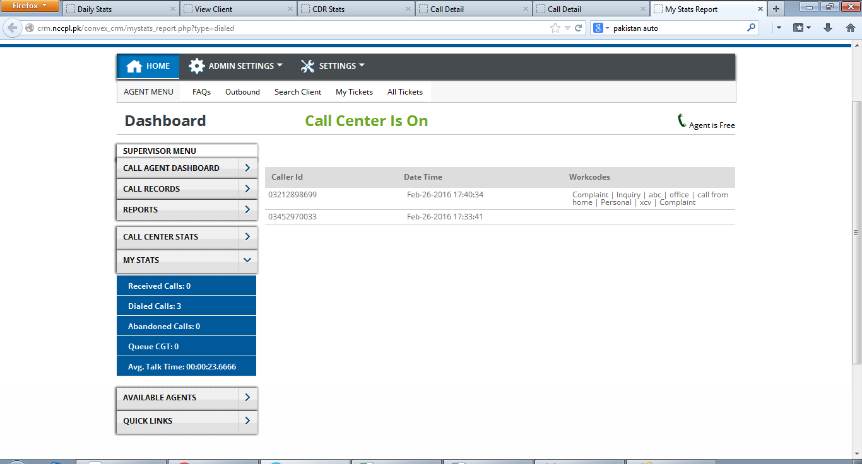

Dialled call : incorrect data.

2 Outbounds calls on a same no. only 1 record is reflecting on report. Have fixed, will test on live also

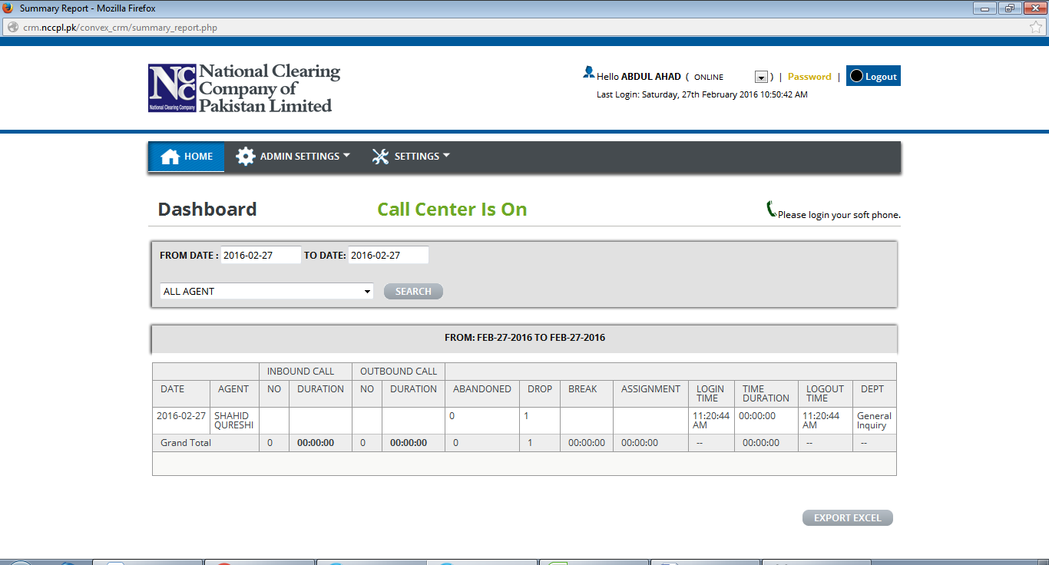

Logout time appearing for the user who is still logged-on to the system.

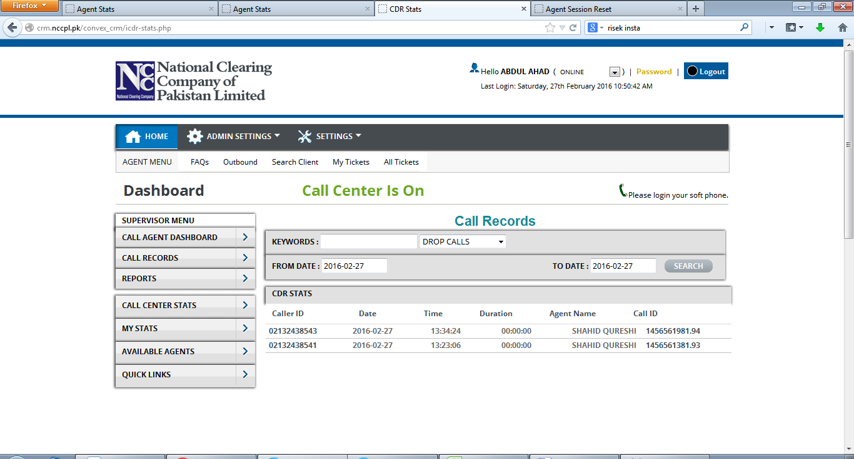

Incorrect reflection of Dropped calls on Summary report.



status remains “ringing” even after an outbound call is successfully connected. Will be fixed on live

Layout issue is solved

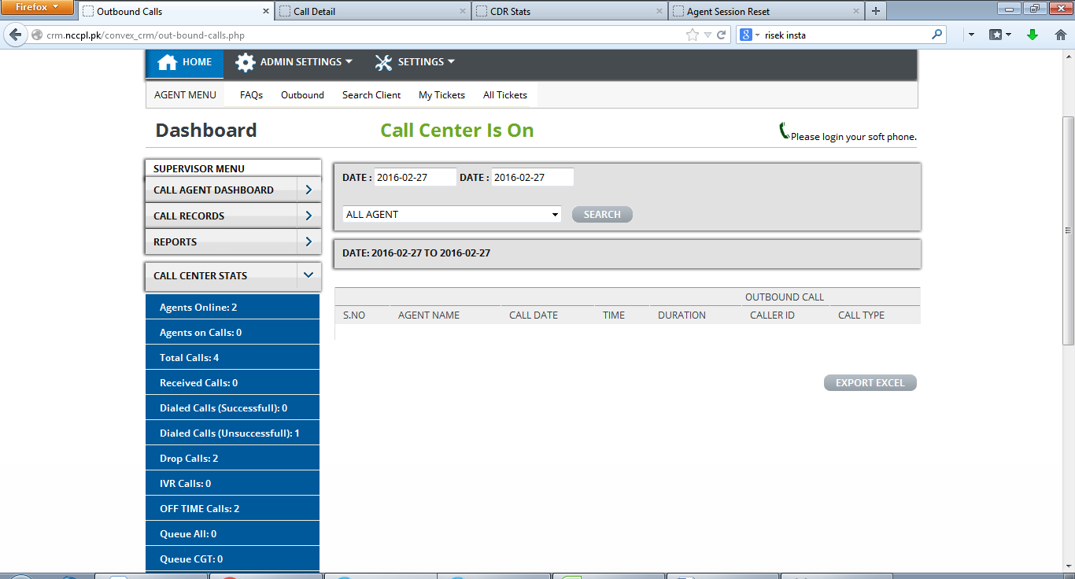

What is “dialled calls (unsuccessfull)”

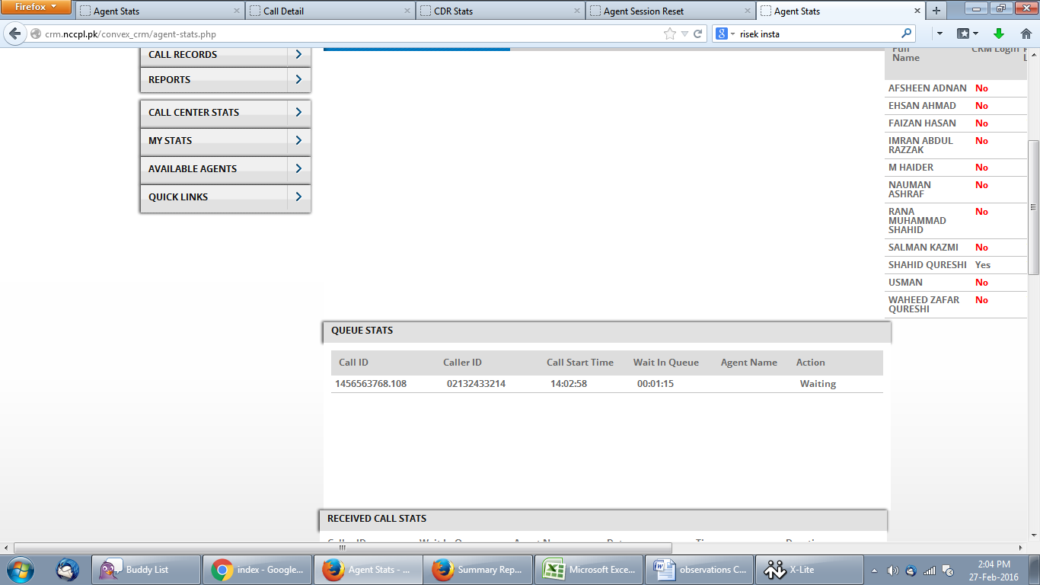

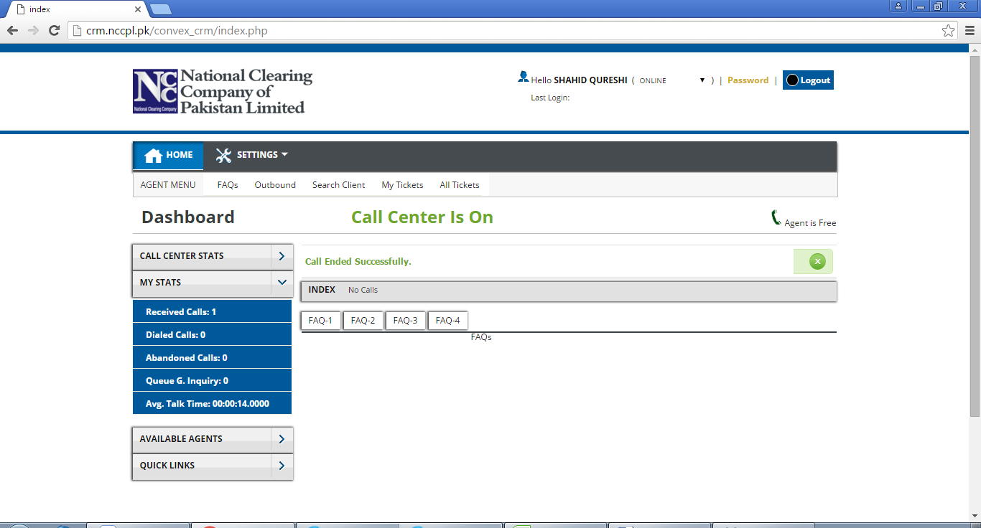

Avg Talk time : incorrect format NOTE Fixed here further will be confirmed at NCCPL

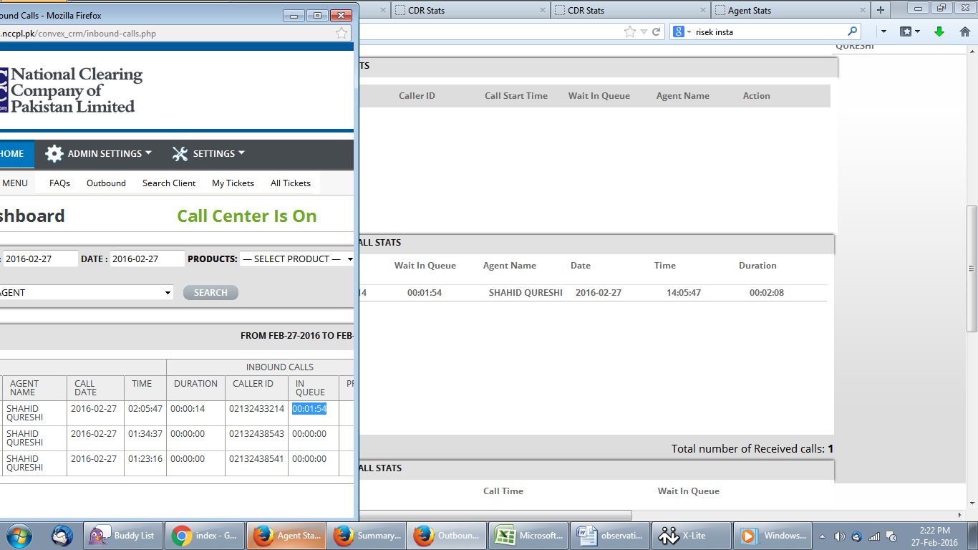

different reflection of duration on Inbound and other reports. Duration shoud be same.

Note: This is misunderstading.

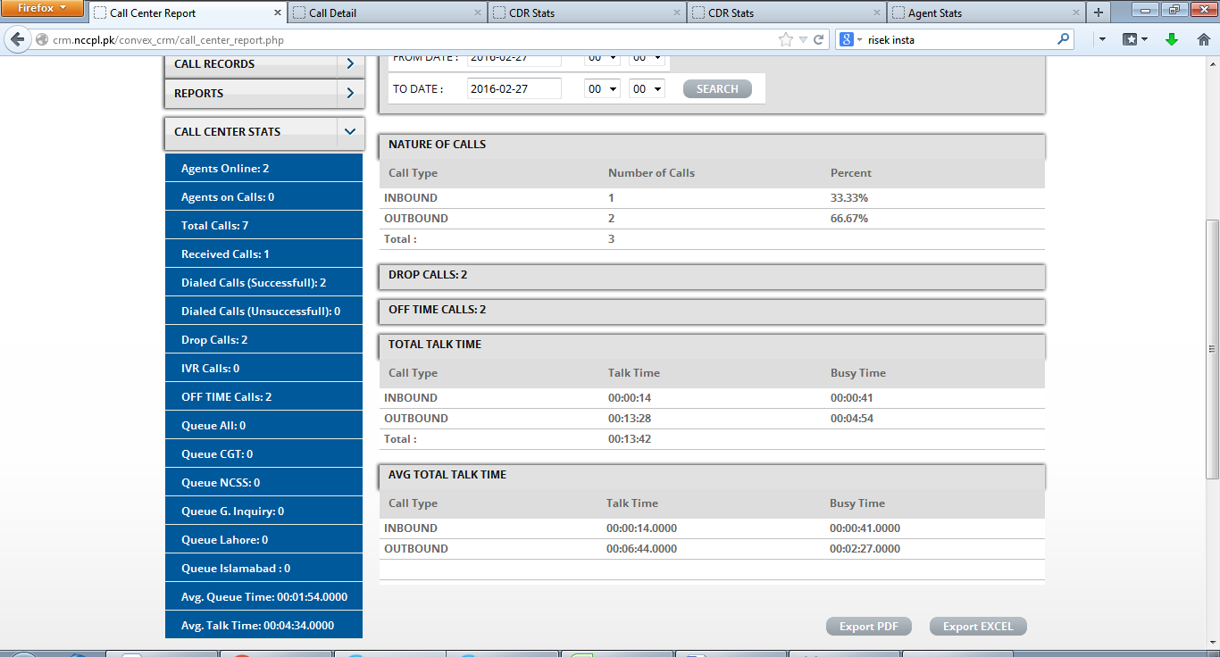

Incorrect Time format Note: fixed and checked,further will be tested on live

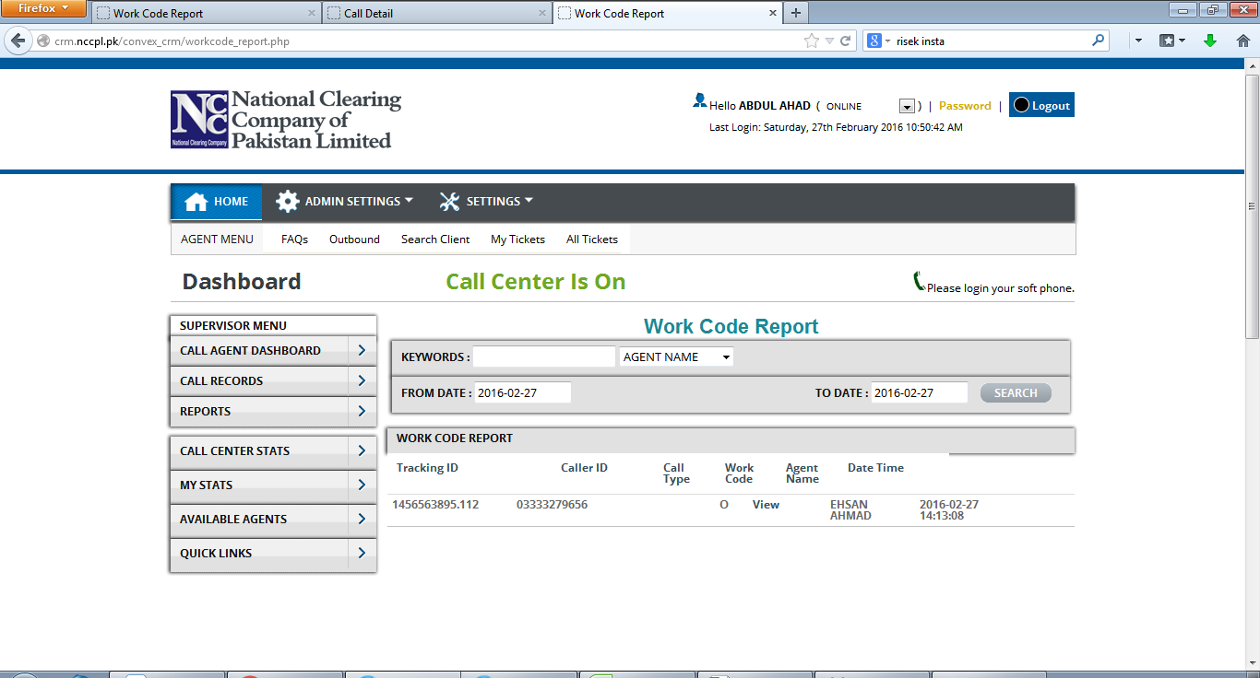

Work code report is not showing complete data.

Work code should reflect on the report directly, rather than a need of Click to view it. Fixed

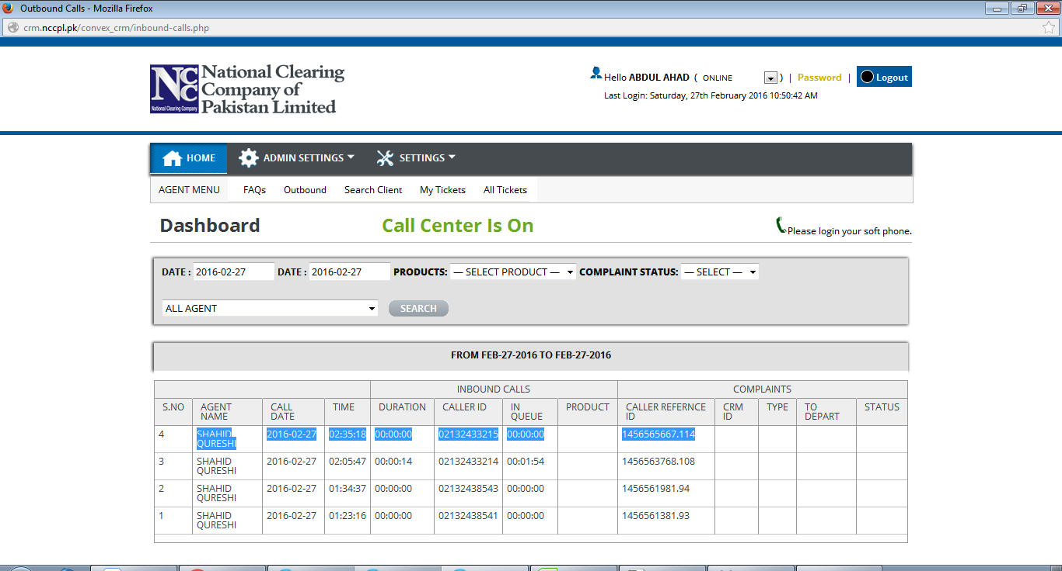

Reflection of Dropped calls on inbound call report.; links are not clickable as per provided format.

No reflection in Product column

Remarks column is missing from the report.

Complaint ID and Complaint Type search fillters are missing.

Data is not reflecting in “To Depart” column

Certain tickets (CRM ID and other data) are not reflecting on the report.

Note: This Need To be Discussed.

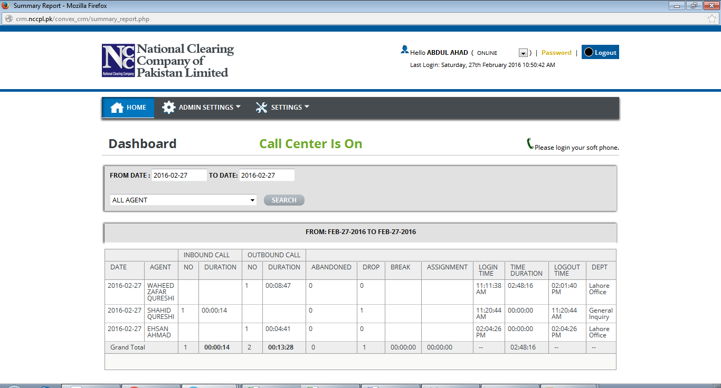

Column “Busy” is missing from the report.

New session line in case of multiple login and logout by a user. Need to be discussed

Login and logout time is not reflecting on the report unless a call is received/dialled. Need to be discussed

Search Filter of Deparment Is missing. Need to be discussed

Real time reflection of Assignement/breaks required on the report.

Logout time should not be shown unless a user log-out of the system.

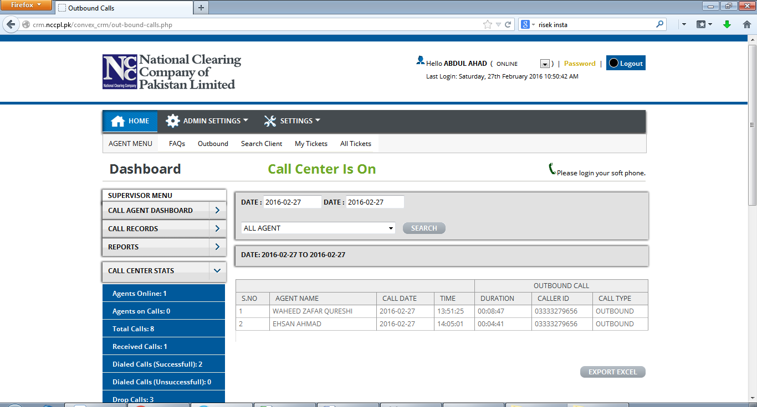Remarks column is missing from the report. Note: need to be discussed

Abandoned Calls

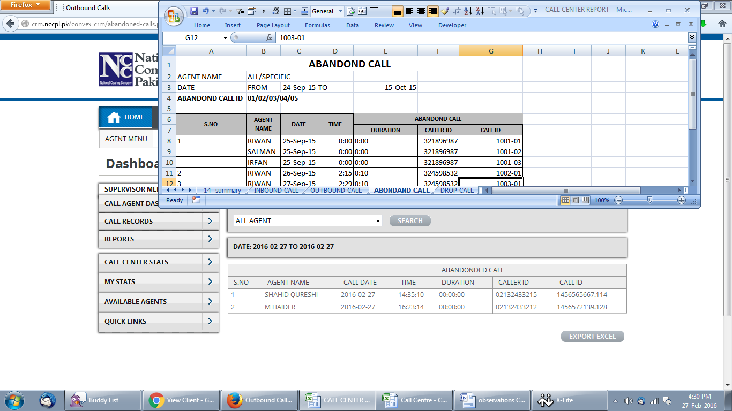

Data not as per provided format.

CRM Detailed Report

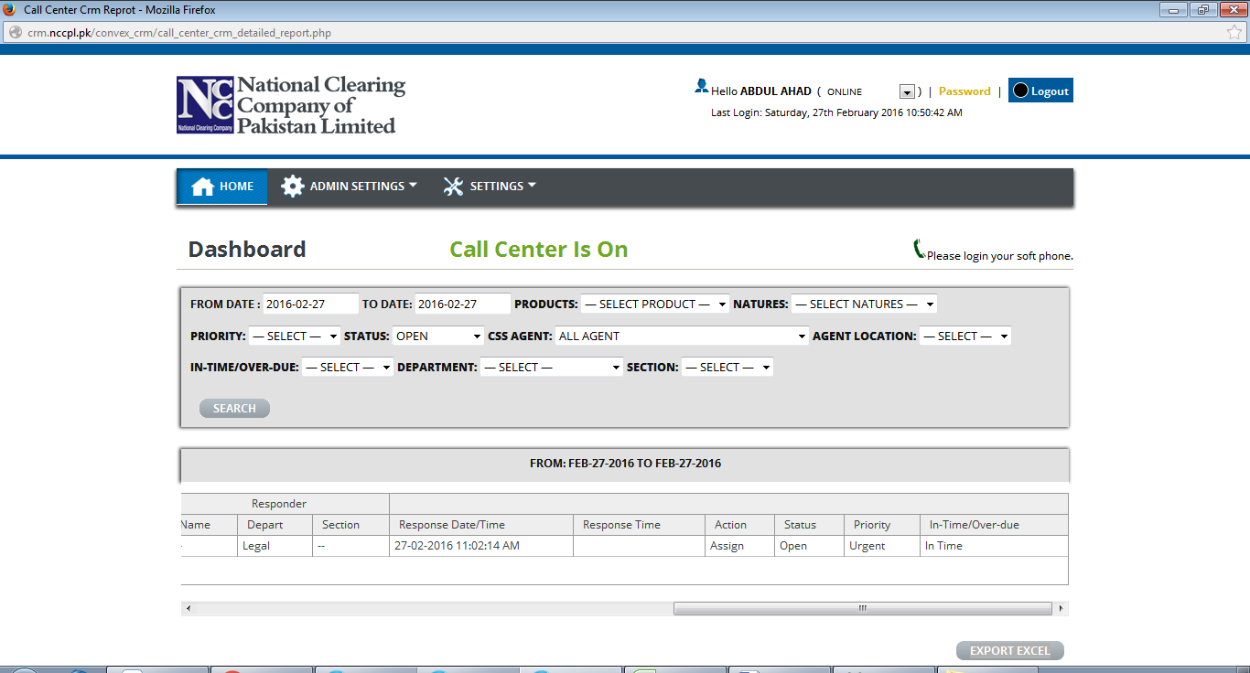

Search Filters not as per provided format

Data is not reflecting on the report , Note: I think its is understanding issue

CRM Summary Report 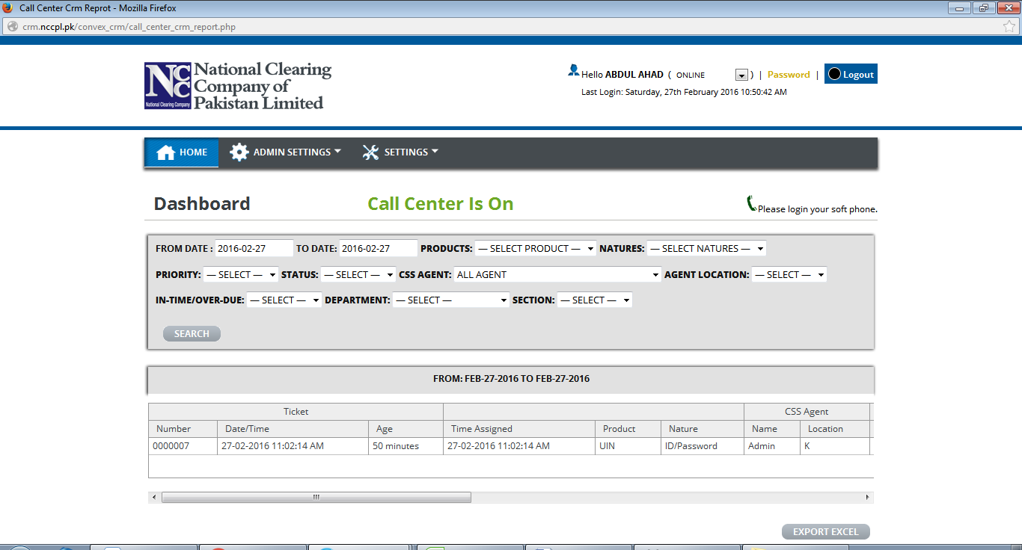

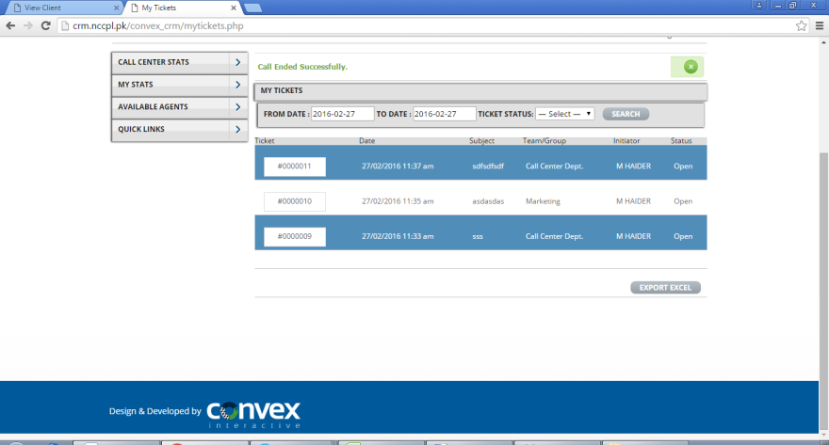

Data is not reflecting on the report Note: understanding issue

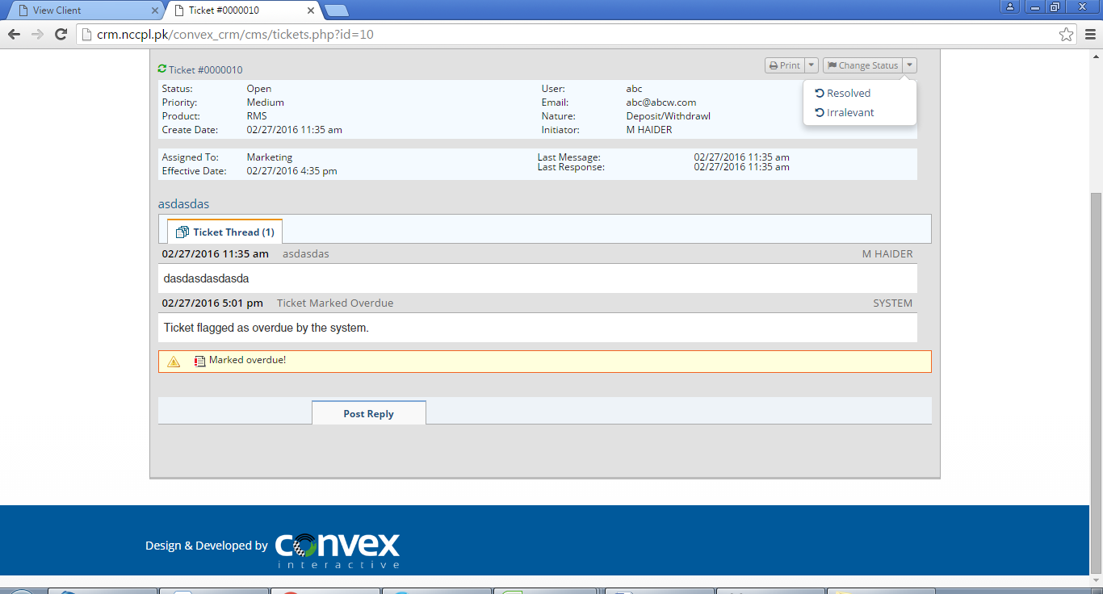

Status change options should not be available to the Responder.

Reply option is not available. I have tested it is working further need to be test on live.

Incorrect time stamping on ticket.

**General Options**

* Password Reset option not available to supervisor.
* Session reset should be made available to all users.
* Inccorect Que Reflection when a call is retured by pressing “#” .
* No field on “Create Client” should be mandatory Note: This is a kind of major change in required I think we should confirm first.
* Field to mentioned Contact person is required Note: Cant Understand what he want to say
* Functionality to define Workcode should be changed to select a single workcode for a call.
* Email adress can be duplicate on “Create Client” page. System currently restricts defining email adress which is already define on the system.
* Call should be received in Queue. Note: Cant Understand what he want to say
* Ticket Creation: When “Others” selected then in “Nature” section, no option to input details is available. Working
* Agent All Ticket: Filter to view All, Created by & Reassigned by should be added in the subject screen. Upon reassigned variation of time is observed. Note: Addtional
* CRM User View: To review the viability of the CRM Dash screen below. Moreover, nothing
* Outbound Call Error: Call is gone through despite the Xlite is not logged in.
* Supervisor IDs are placed in CGT Department,
* CRM User View: To review the viability of the CRM Dash screen below. (Graphs)

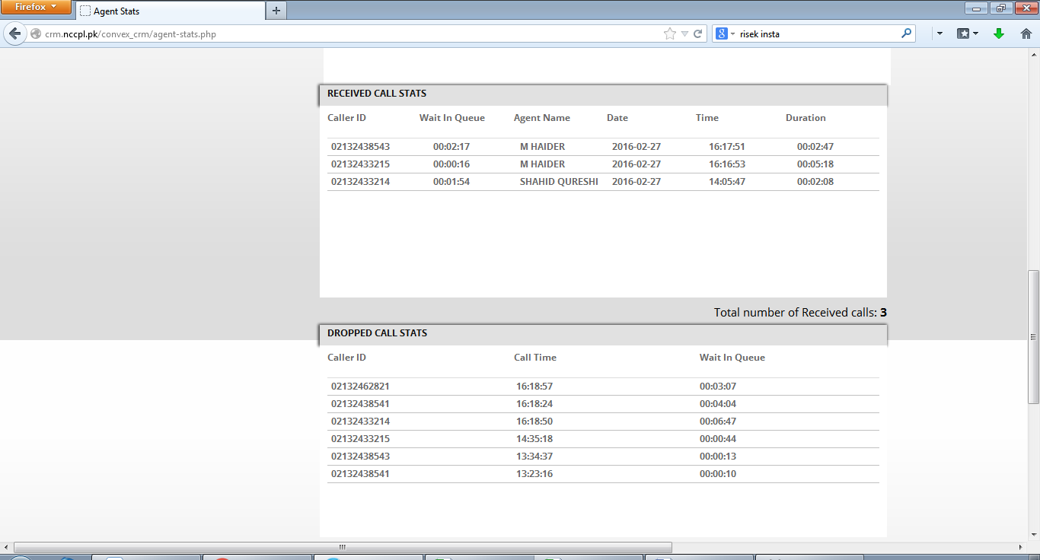

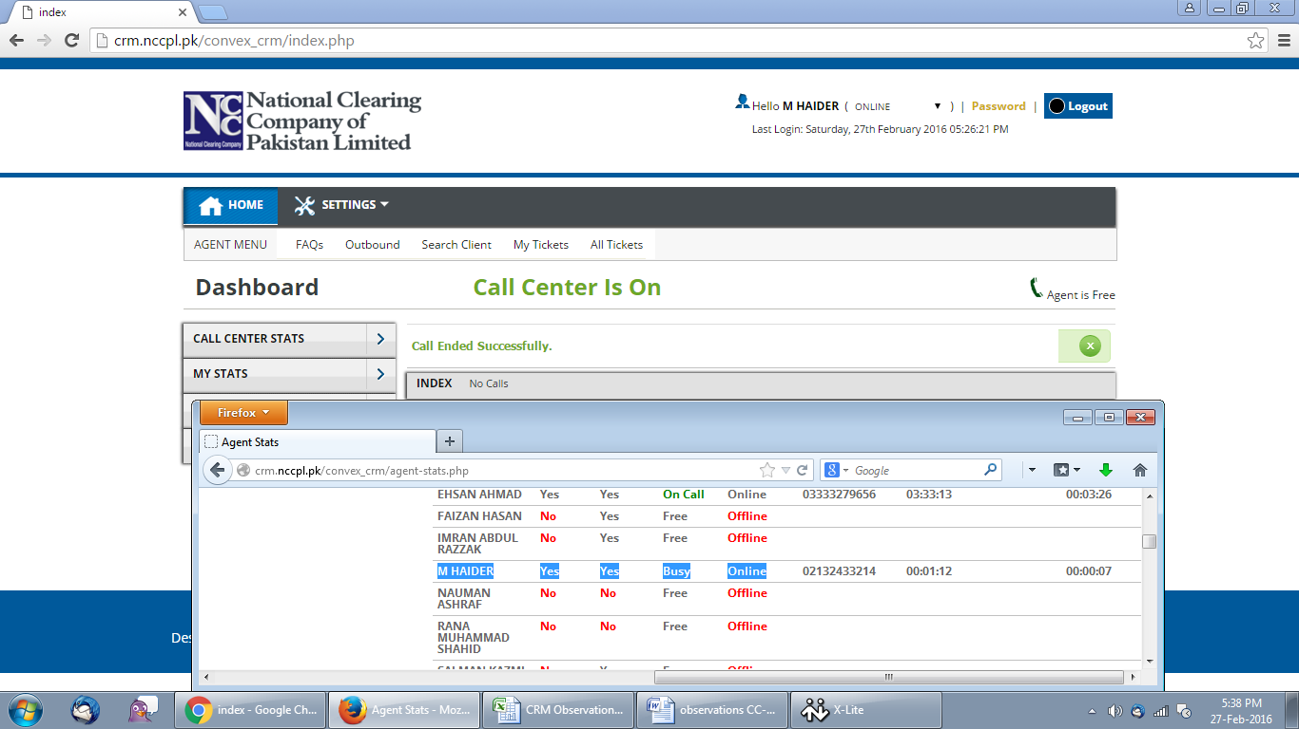incorrect Call status when call is trasnferred.

Frequent Call disconnect observed on call trasnfers.